The HINT project presents the solo exhibition:
Transparenser (Transparencies) by Kasper Kjeldgaard (DK)

12 May – 9 June 2018
PLADS artspace. Vestergade 62, Aarhus C

Opening: Friday 11 May 16:00 – 18:00
Opening hours: Wednesday – Friday 13:00 – 18:00, Saturday 11:00 – 15:00

Artist talk: Kasper Kjeldgaard in dialogue with Ane Fabricius Christiansen, ceramic artist
Wednesday 6 June 16:30 at the artist’s studio. Jægergaardsgade 156M, Aarhus
Exhibition guide by the artist: Friday 25 May 15:00

The HINT project presents the solo exhibition Transparenser (Transparencies) – an installation of Kasper Kjeldgaard’s works, specifically developed for the PLADS artspace.
Kasper Kjeldgaard works with both experimental art and functional design oriented towards the same materials and techniques. He is interested in working with a number of fundamental principles/laws of nature which are basic to the way our world functions at the structural and physical level; for example gravity, rotation, centring and friction. He explores and challenges these themes in his work with compositions such as mobiles and stabiles, as well as in more specific design work, for example with lamps.
In this work, knowledge of the materials and the refinements of craftsmanship play a crucial role. The materials are carefully selected on the basis of their intrinsic qualities; for example paper is light and has a large surface, brass is heavy and smooth, while wax has high friction. These properties are explored, manipulated and combined so the materials play together, not only aesthetically, but to a high degree also functionally, in both artworks and design objects.
The exhibition title Transparenser refers to Kasper’s treatment of the works, and points for example to the transparency of the materials. But the title also refers to transparency understood as openness and honesty in the design processes, and the fact that the way the works are constructed conceals nothing but points back to the techniques and the time embedded in the objects.
In the exhibition Kasper is interested in investigating the transitions and fusions between the materials paper, brass and wax. The wax that soaks the paper gives it a new stability and rigidity, and the paper gives the fluid wax expression in space, or surface. The two materials so to speak transfer their properties to each other and become a composite third thing; a material where it is not only the visual and tactile expression that is interesting, but very much also the static and functional properties that are investigated in order to understand the potentials of the material.
About Kasper Kjeldgaard:
Kasper Kjeldgaard graduated as a furniture designer from the Architecture and Design School of the Royal Danish Academy of Fine Arts in 2016. Since then he has participated in a number of exhibitions in Denmark and abroad and has been shown at design fairs such as Miami/Basel 2016, FOG San Francisco 2017 and Mindcraft in Milan, 2017. In September 2017 he had his first international solo exhibition at the Patrick Parrish Gallery in New York and in 2018 he is one of 15 Danish designers and artist-craftsmen chosen to participate in Mindcraft 2018 in Milan.

High-resolution images can be downloaded at:
https://www.dropbox.com/sh/lvq49b1shejalsp/AAD2-trf--4NkooE0gL2HpXga?dl=0

See also:
HINT project http://hintproject.dk/
Kasper Kjeldgaard http://kasperkasper.com

The exhibition is supported by
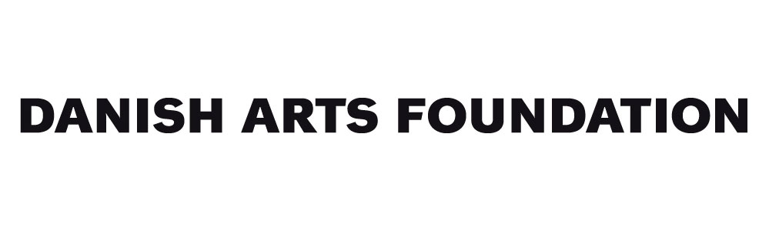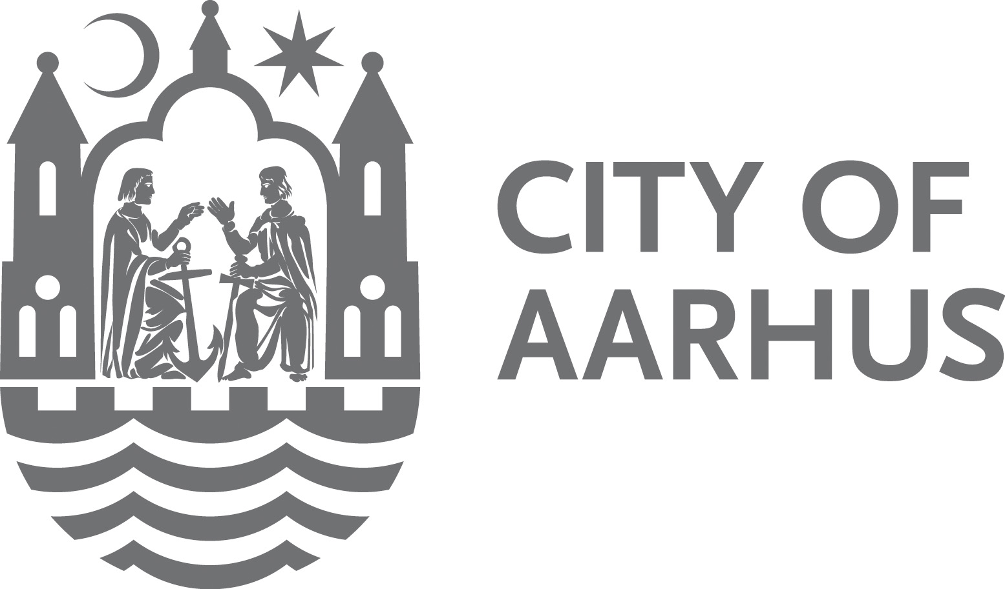
Yours sincerely,

HINT project
Sanne Ransby + Mariko Wada
hint@hintproject.dk
Tel. +45 2990 2519 (Sanne Ransby)

